Tab 1



AI Driven Cyber Security & Ethical Hacking Career Track Program

Module: 01
Assignment No: 01
Assignment Title: Case study on Shwapno data breach 2025

Date: 10-10-2026
Submitted By: Mainull Islam
Submitted To: Safwan Muntasir Sir

Table of content

- What happened in this incident?

- Which organization was affected?

- What types of information were exposed or stolen?

- Who were affected by this incident?

- What problems could customers face because of this data breach?

- How might the incident affect the company's reputation and business?

- What actions did the company take after the incident?

- What lessons can other organizations learn from this event?

- In your opinion, what should organizations do to protect customer
information?

- Mention the lesson learned from this incident.

Task: 1

1. What happened in this incident?
Ans: Shwapno a well known supermarket chain in Bangladesh got affected by ransomware attack in August 2025. This incident started as the attackers targeted their employees through phishing emails that contained malicious links. The attackers were apparently able to use this method to gain access to the company’s system. When they succeeded to gain access to the company system they immediately locked down the system by ransomware and stole a lot of data. Later they demanded a ransom of 1.5 million USD to prevent sensitive data release. The company did not agree to pay the ransom. Their MIS team immediately disconnected the system and removed the malware. In March 2026 the attacker published 410 GB of sensitive data on the dark web. Some of the data later appeared on social media and websites.

2.Which organization was affected?
Ans: The organization affected by this incident was Shwapno. Shwapno operates under ACI Logistics ltd, which is a part of ACI group.

3.What types of information were exposed or stolen?
Ans: According to media reports, different types of information were stolen. Customer information included names, mobile phone numbers and purchase histories.Supplier information, business contracts, daily sales records and bank-deposit information. Some human resources documents and internal company policies were also reportedly included.

4.Who were affected by this incident?
Ans: The first sufferer of this incident is Shwapno’s customer. Their names, phone numbers and purchase histories were included in the leaked information. Customers therefore face privacy and security concerns.
Employees may also have been affected because some HR and internal company documents were reportedly part of the leaked data.
Suppliers and business partners could also be affected because supplier information and business contracts were among the leaked documents.

5. What problems could customers face because of this data breach?
Ans:Customers could face several problems because of the exposure of their personal information. One big concern is phishing . If a criminal knows your personal information, they can conduct more convincing fake messages and phone calls. Customers could also be targeted different types of scams. Another problem is the loss of privacy. Purchase history can reveal a person's shopping habits and preferences. If this information becomes publicly available, customers may feel uncomfortable or unsafe.

6. How might the incident affect the company's reputation and business?
Ans: This incident can affect the company reputation tremendously. So news of this major cyber attack can reduce customer confidence. Some customers may become concerned about using the company's digital services.The company may also face financial costs as a result of the incident. It may need to spend money on cybersecurity experts, forensic investigations, system recovery, legal services and additional security measures.
The leaked business information could create another problem. If confidential contracts, supplier information or sales-related records are exposed, competitors or criminals could potentially use that information against the company.

7.What actions did the company take after the incident?
Ans: After discovering the attack company’s MIS team took steps to protect the system. They disconnected the system and removed the malware. The company refused to pay ransom. After the leaked data became public, Shwapno and ACI Logistics became involved with law enforcement and investigation efforts. They filed a General Diary with the Tejgaon Industrial Area Police Station. The matter was later transferred to the Detective Branch Cyber Unit for further investigation.
The company also warned customers about possible scams and advised them to be careful with suspicious calls, messages and links.

8. What lessons can other organizations learn from this event?
Ans: There are several important lessons that other organizations can learn from the Shwapno incident.
First, employee awareness is very important. Employees should receive regular training about suspicious emails, links and attachments.
Second, companies should use multi-factor authentication for important accounts. If an employee's password is stolen, another security layer can make it more difficult for attackers to enter the system.
Third, organizations should separate important systems from ordinary employee computers. Customer databases and financial systems should have strong access controls.

9.In your opinion, what should organizations do to protect customer

Information?
Ans: In my opinion, organizations should take customer data protection very seriously because personal information can cause significant problems if it falls into the wrong hands.
Sensitive customer information should be encrypted so that even if attackers gain access to the data, it is more difficult for them to use it.
Organizations should also use strong passwords and multi-factor authentication for employees. Access to customer databases should be limited to employees who actually need that information for their work.
Companies should regularly update their software and security systems and use tools that can detect suspicious activity.

10. Mention the lesson learned from this incident
Ans: The main lesson I learned from this incident is cybersecurity is not only the responsibility of IT department. Everyone of this organization has a role in protecting information. A simple phishing email can potentially lead to a much larger cyberattack.
Another important lesson is that removing ransomware from a computer does not necessarily mean that the incident is completely over. If attackers have already stolen information, the data can still be used or published later.
Lastly, companies need to understand that protecting customer information is part of maintaining customer trust. Once customer trust is lost, it can take a long time to rebuild.

Task: 2

Related photo and screenshot

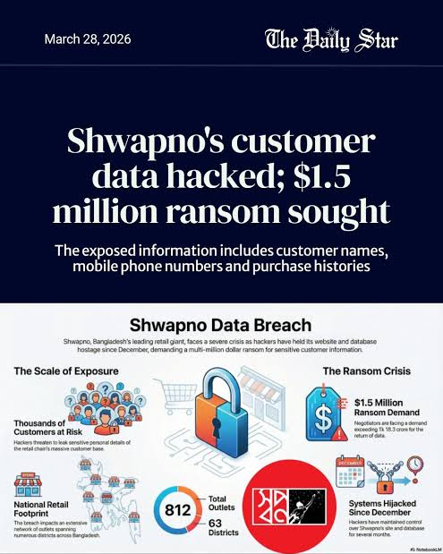

Photocard downloaded from Daily Star
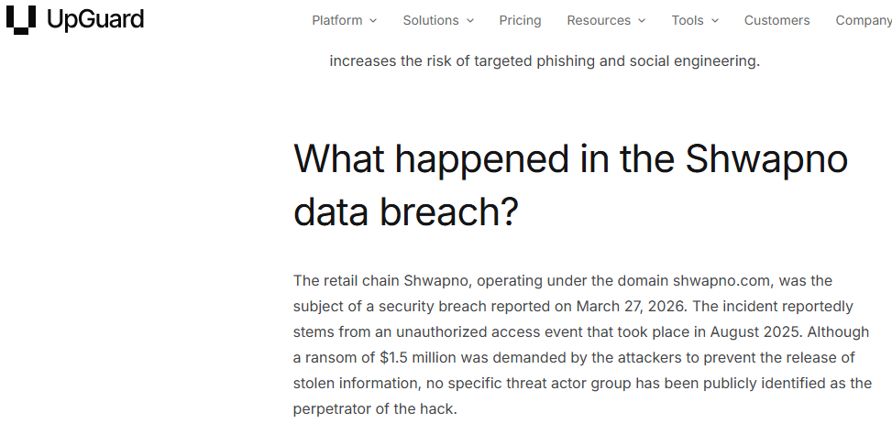

Upguard report screenshot

Task: 3

References
https://www.tbsnews.net/bangladesh/retail-chain-shwapno-hit-customer-data-breach-hackers-seek-15m-1396081

https://www.thedailystar.net/news/crime-justice/news/shwapno-files-gd-seven-months-after-cyberattack-exposed-customer-data-4138566

https://www.upguard.com/news/shwapno-data-breach-2026-03-31

https://www.unb.com.bd/category/Business/shwapno-website-hacked-customer-data-leaked-online/182441

